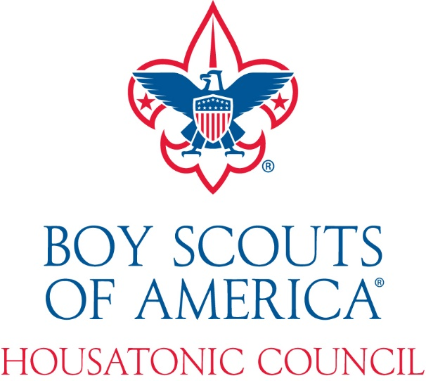
2019 FALL RECRUITMENT PLAN
PRESENTED BY: CAROLE CAFARO
111 New Haven Avenue, Derby, CT 06418
July 31, 2019

2019 Fall Recruitment Plan

Fall Recruitment is an important step in growing the Scouting program in the Housatonic Council. Let’s open our doors and give every youth in the Valley an opportunity to join Scouting.

In the Fall our Cub Scout Packs recruit Lions, Tigers Wolves, Bears and Webelos. We should also concentrate on recruiting Scouts, Venturing Crew Members and Explorers. It’s a new school year and parents and youth are looking for new opportunities.

NEW FOR 2019

Online Registration:

Online registration is here. The online registration system is designed to make it easy for families to join Scouting. The system walks the family through the application and payment process. When an application is submitted, the unit Key 3 will receive a notification in their My.Scouting inbox once a day letting them know they have an action to take.

It is important that key members of your unit make sure their My.Scouting is current and that the key positions have the responsibility they need to process online applications. More information can be found under Online Registration at www.scouting.org or contact Carole Cafaro at carole.cafaro@scouting.org or at the council office.

Family Scouting:

The Cub Scouting program is open to all youth. Youth now have access to the character development and values-based leadership that Scouting promises.
Are you welcoming girls into your Pack this Fall? Have a discussion with your Chartering Organization. If you need help conducting the conversation with your Chartering Organization, contact Carole Cafaro at carole.cafaro@scouting.org. But, please remember this is a local organization and unit decision and the Council will not make it for the organization or the unit.

Procedures for Fall Recruitment

Setting Up Your Unit Open House – All Units

- Review your Calendar and plan to hold two open houses (recruiting nights). This is key we need to offer at least two opportunities:

  - Plan for the first Open House the second or third week of September at your meeting location.
  - Schedule the second Open House to join at your meeting location. The recommendation is for the last week of October but no later than November 15.

- Begin securing your meeting place for the Open House NOW if possible.

- Using the Fall Flyer Request Form attached. Provide us with the following information:

FALL RECRUITING INFORMATION:
Unit # ________ Community_________________
Contact Person Name ____________________ Phone _______________
Email (Print)_______________________________
Place Recruiting Opportunity #1________________________________
Address_________________________ Date_________ Time _________
Place Recruiting Opportunity #2________________________________
Address_________________________ Date_________ Time _________

The council will use this information to create flyers for distribution in the school districts in the Kindergarten through 8th grade classes.

- Once we have all information we will produce flyers and get the permissions needed for distribution. Please note due to the process of securing permission from the School Districts, the Fall Flyer Request Form should be submitted 21 days prior to the Open House date. Please keep this in mind.

- The Council will secure permission to have flyers distributed in the schools or through the electronic e-mail system.

- We try to create only one Cub Scout, and one Scout flyer for each school district. All units in that school district will be listed.

- All flyers will have the www.beascout.org and “Scout Me In” logo.

- Please go to www.my.scouting.org and update your unit locator pin information. Each unit is responsible for updating their information. If you require more information on beascout.org, please contact Carole Cafaro at carole.cafaro@scouting.org.

  - The Housatonic Council will also provide your unit with additional flyers for your Scouts and families to share peer to peer and family to family. It’s so much nicer when friends join. Scouts who recruit a friend, they will have a chance to win either a T-Shirt or a gift card to the Sports Center and a “Recruiter” patch to recognize their achievement.

Class to Class Presentations or School Assemblies prior to your Open House
(Cub Scout programs this works best)

Our BEST results have been class to class presentations.

We ask that as a Unit Leader please try to secure permission for class to class presentations at the school, or an assembly program. The Housatonic Council requests that a Unit Leader join us for these presentations.

Why? After the presentation is made, we want to be sure that a friendly face that the youth recognize is at the Open House night, so the youth is more at ease to join.

  - Class to class presentation is a 5 minute per class presentation to share with the whole class the fun of Scouting.

  - Assembly programs could be 20 to 30 minutes per grade.

The Housatonic Council will be contacting the School Districts to secure these presentations, but through experience, Scouting has received a better response when a parent from the school makes the request.

What to do on the Open House Night and After

- Prior to the Open House
  - Prepare displays for the recruiting night.
  - Complete a Unit Leadership inventory. Know your leadership vacancies, you may find someone to fill the role needed.

- Onboarding Packet - We will provide you with an Onboarding Packet with important information for new families. In addition to these items, you should add:
  - Your unit budget
  - Joining cost
  - Unit calendar ready for distribution

- Hold the recruiting night. Collect appropriate applications and prorated fees ($2.75 per month, $1.00 for Boys Life (optional).

- After the Open House Night is completed share with your Unit Commissioner the number of youth applications completed and submit the completed applications to the Housatonic Council.
  - Make sure the applications are signed by the:
    - Parent
    - Unit Leader

- Prior to submitting the completed Adult applications make sure the following is completed:
- Make sure the applications are signed by the:
    - Adult
    - Committee Chair
    - Chartered Organization Representative

- Social Security Number is complete
- Youth Protection Certificate is submitted

Please send to Carole Cafaro an e-mail at carole.cafaro@scouting.org.confirming your Pack, or Troops participation.

Venturing: What is Venturing?

Venturing is a youth development program of the Boy Scouts of America for young men and women who are 13 and have completed the eighth grade, or age 14 through 20 years of age. Venturing's purpose is to provide positive experiences to help young people mature and to prepare them to become responsible and caring adults.

Venturing is based on a unique and dynamic relationship between youth, adult leaders, and organizations in their communities. Local community organizations establish a Venturing crew by matching their people and program resources to the interests of young people in the community. The result is a program of exciting and meaningful activities that helps youth pursue their special interests, grow, develop leadership skills, and become good citizens. Venturing crews can specialize in a variety of avocation or hobby interests.

Each chartering organization of a Cub Scout Pack and Boy Scout Troop should consider adopting the whole family of Scouting and add a Venturing Crew to the existing units for teenagers, Male and Female.

Goals of Venturing

Young adults involved in Venturing will:

- Learn to make ethical choices over their lifetimes by instilling the values in the Scout Oath and Scout Law.
- Experience a program that is fun and full of challenge and adventure.
- Become a skilled training and program resource for Cub Scouts, Boy Scouts, and other groups.
- Acquire skills in the areas of high adventure, sports, arts and hobbies, religious life, or Sea Scouting.
- Experience positive leadership from adult and youth leaders and be given opportunities to take on leadership roles.
- Have a chance to learn and grow in a supportive, caring, and fun environment.

Methods

The aims of the Boy Scouts of America are to build character, develop citizenship, and foster personal fitness. The Venturing methods listed below have been carefully designed to achieve the aims of the Boy Scouts of America and meet the needs of young adults.

- Leadership. All Venturers are given opportunities to learn and apply proven leadership skills. A Venturing crew is led by elected crew officers. The Venturing Leadership Skills Course is designed for all Venturers and helps teach them in an active way to lead effectively.

- Group Activities. Venturing activities are interdependent group experiences in which success is dependent on the cooperation of all. Learning by "doing" in a group setting provides opportunities for developing new skills.
- Adult Association. The youth officers lead the crew. The officers and activity chairs work closely with adult Advisors and other adult leaders in a spirit of partnership. The adults serve in a "shadow" leader capacity.

- Recognition. Recognition comes through the Venturing advancement program and through the acknowledgement of a youth's competence and ability by peers and adults.

- The Ideals. Venturers are expected to know and live by the Scout Oath and Scout Law. They promise to be faithful in religious duties, treasure their American heritage, help others, and seek truth and fairness.

- High Adventure. Venturing's emphasis on high adventure helps provide team-building opportunities, new meaningful experiences, practical leadership application, and lifelong memories to young adults.

- Teaching Others. All of the Venturing awards require Venturers to teach what they have learned to others. When they teach others often, Venturers are better able to retain the skill or knowledge taught, they gain confidence in their ability to speak and relate to others, and they acquire skills that can benefit them for the rest of their lives as a hobby or occupation.

Ethics in Action
An important goal of Venturing is to help young adults be responsible and caring persons, both now and in the future. Venturing uses "ethical controversies" to help young adults develop the ability to make responsible choices that reflect their concern for what is a risk and how it will affect others involved. Because an ethical controversy is a problem-solving situation, leaders expect young adults to employ empathy, invention, and selection when they think through their position and work toward a solution.

HELP US IDENTIFY ORGANIZATIONS IN THE VALLEY WHO CAN OFFER:

STUDENTS & PARENTS

Exploring is a unique career exploration program for young men and women ages 14-20. It provides students with an opportunity to learn about a wide variety of career fields and network with professionals already working in those fields. You get hands-on experience to determine whether or not a particular career field is right for you. You develop valuable networking contacts with professionals working in your selected career fields, and you get to know other teenagers and young adults sharing your same interests and aspirations. Exploring can be the first step in identifying career possibilities while having fun in an exciting and informal environment.

STUDENT BENEFITS:

• Strong Personal Values and Character Development
• Build self-worth and self-confidence
• Leadership development
• Social development
• Unique career experiences, networking & internships
• Personal development
• Volunteer community service
• Group collaboration and teamwork

Most Career Exploring programs align with the high school calendar and begin in the fall, while some also offer summer activities, conferences, internships and other events. Most meet once or twice a month throughout the school year.

There are dozens of career fields and over 100 occupations to choose from. The following are examples of some of the most popular Career Exploring fields:

Accountant / CPA
Architect
Attorney / lawyer
Author / Poet
Automotive Mechanic
Aviation
Barber / Cosmetologist
Business (general)
Child Care
Communications
Computer Engineer / Technician
Computer Programmer
Engineering (General)
Fashion Designer / Model
Federal Law Agent
Fire Service
Government
Health Careers (general)
Law Enforcement
Mechanical Engineer
Medicine – Sports
Musician
Nurse
Pharmacist
Photographer
Physical Therapist
Physician
Professional Athlete
Science
Skilled Trades
Small Business Owner / Entrepreneur
Teacher
Veterinarian

Each year the local Career Exploring Office, in cooperation with area middle and high schools, can administer career interest surveys to your students.

Students select their top two career choices from over 100 career options. This information is then used to invite these students to join local Career Exploring programs. There are currently more than 4,600 Career Exploring Posts across the country.

We are attempting to offer surveys in each of our school districts in the Valley this fall. For more information, please contact Carole Cafaro at the Housatonic Council Office 203-734-3329.

SAMPLE FLYERS FOR 2019
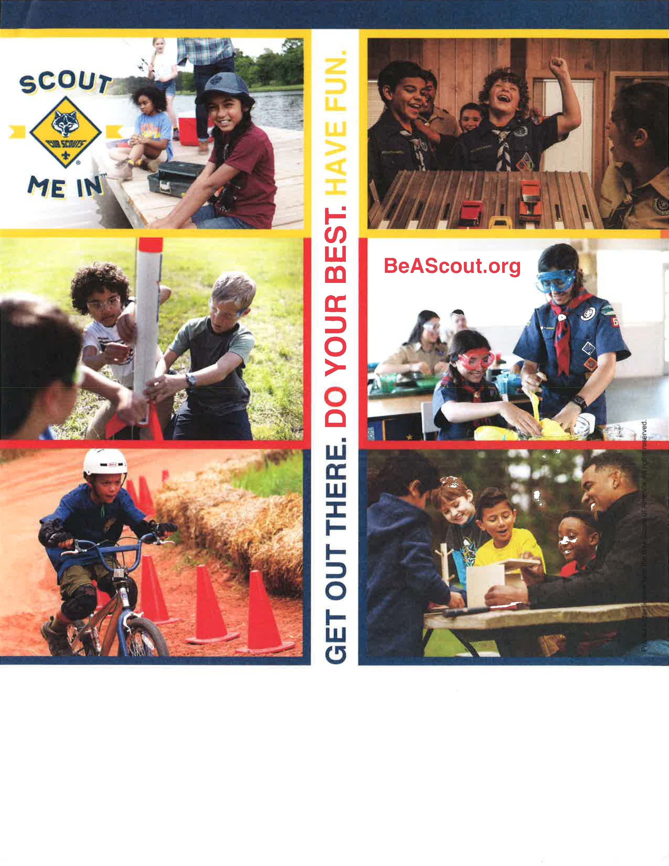
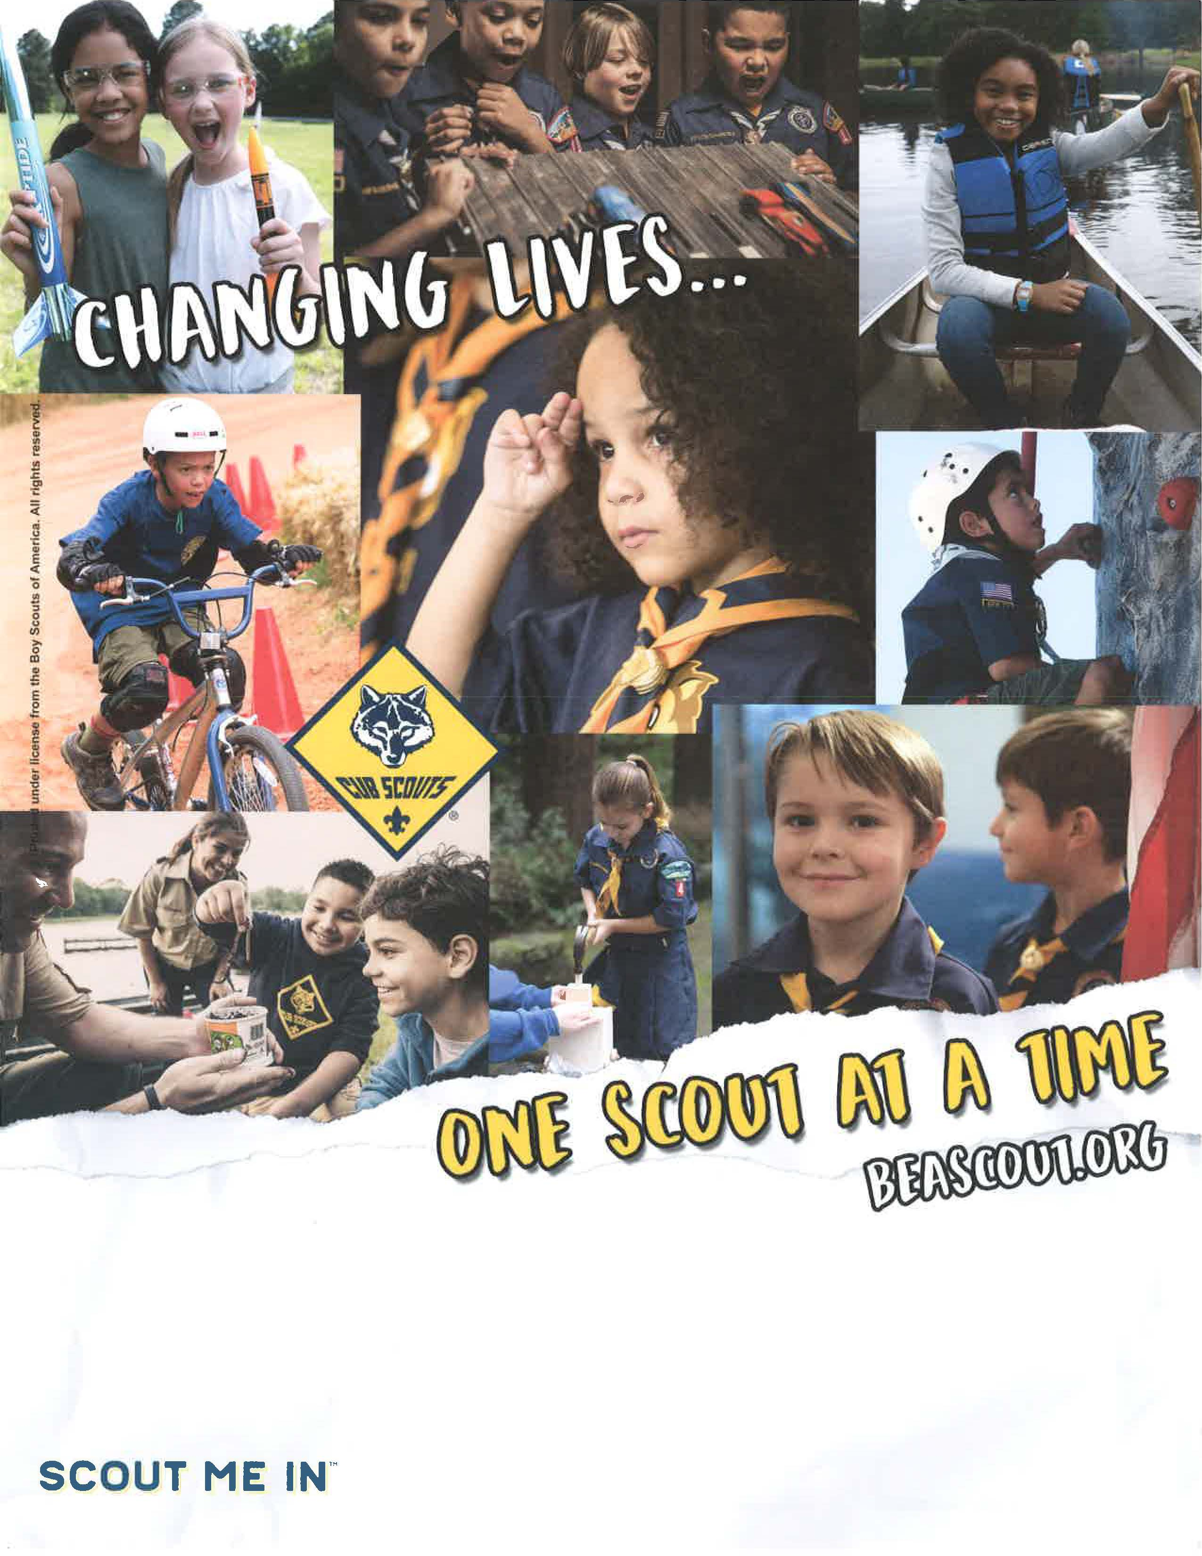
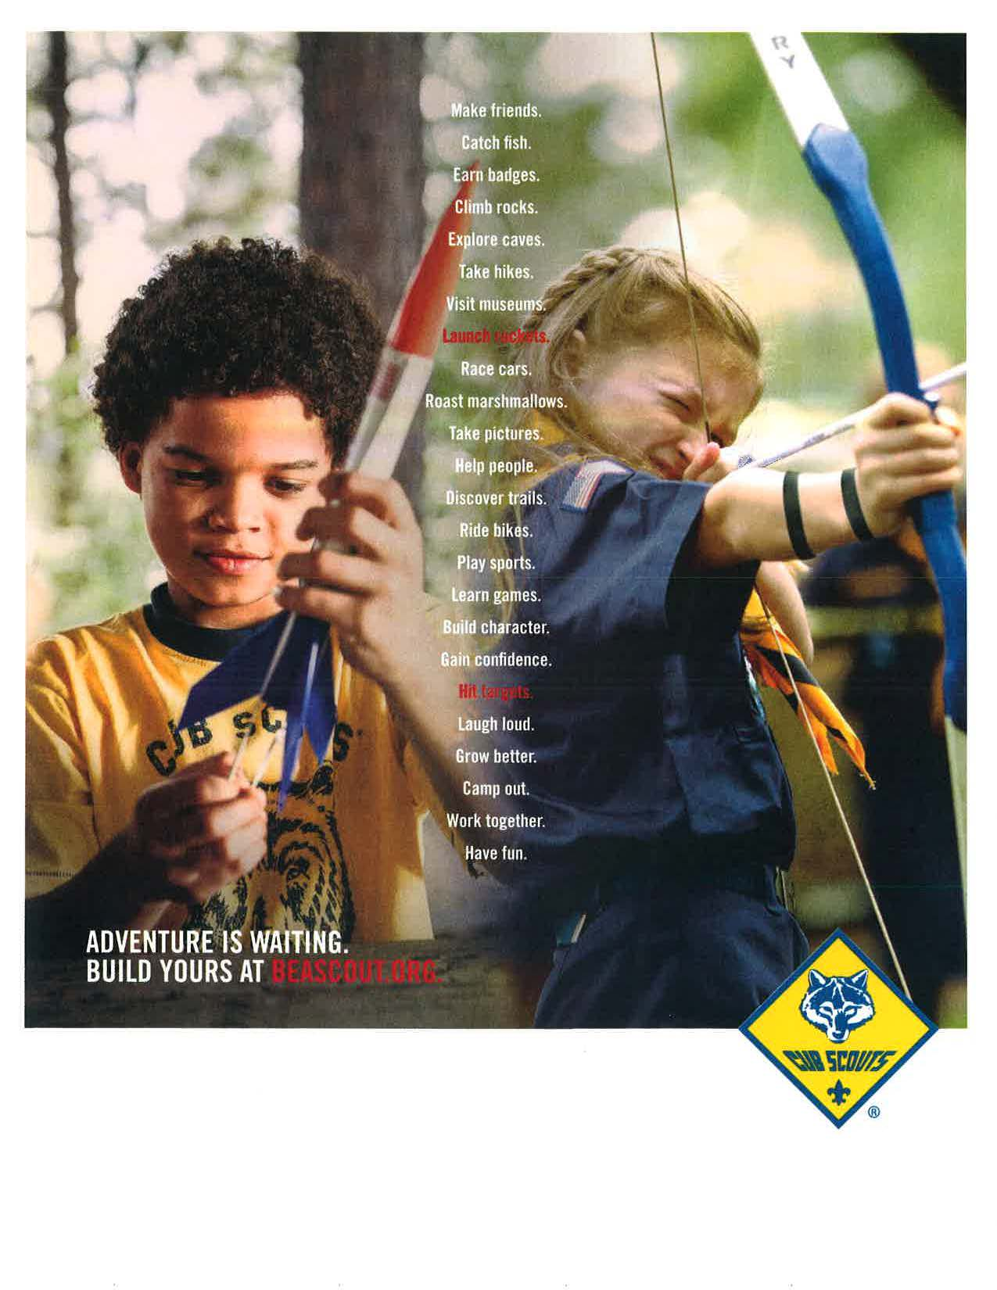

FALL FLYER REQUEST FORM

Unit Type / Unit #___________________________________

Person filling out form

Name______________________________

Unit Position ______________________

Phone #_________________________ E-mail _______________________________

Best time to call___________________

Would you be able to schedule Scout Talks at the schools you are recruiting from?
❒ YES   NO

What school or organizations do you want flyers to go to? ___________________________________________________________
❒ Would you like additional flyers to distribute locally?

If so how many flyers: ______________

Please complete the following information for your Open House Flyers:

When:

Where:

Address:

Date/Time:

Contact Name & Phone #

to have your FALL Recruitment Flyer delivered timely

please make your REQUEST 14 DAYS PRIOR TO OPEN HOUSE

Please note flyers take at least 14 days to process. The process includes obtaining approval from the school districts. Please fill out all the information and e-mail to Carole Cafaro at carole.cafaro@scouting.org.

