111 New Haven Avenue, Derby, CT 06418
Phone: 203-734-3329 OR Email: Carole.Cafaro@scouting.org

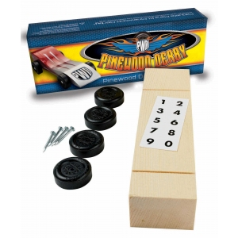
PINEWOOD DERBY KIT SALE

PURCHASE PINEWOOD DERBY KITS FOR YOUR UNIT AT

$3.75 PER KIT
Pinewood Derby kits retail for $4.49 per kit

All orders must be place by December 4, 2020.

DATE ______________ PACK # ______________

CONTACT _________________ PHONE #_________________

Email Address: __________________________________

Total Number of Cars: _______ X $3.75 per kit = $ _________

Form of Payment:
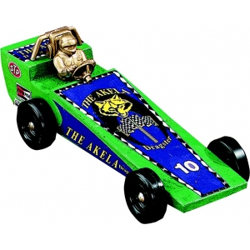
- CC - Call Council office with your Credit Card information
- Check
- Cash
- Unit Account

